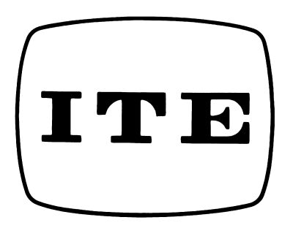
The Institute of Image Information and Television Engineers

Copyright Transfer Form

Title of Paper (hereinafter, ”the work”)

Complete list of authors

Publication

The undersigned hereby has read and understands the Copyright Transfer Rule of the Institute of Image Information and Television Engineers, and warrants that

- The person(s) listed above agree(s) to assign all copyright rights of the work provided in the Japanese Copyright Law Articles 21 through 28, including the rights of reproduction, distribution, transfer of ownership, translation, adaptation, and the original author to exploit derivative work. The authors may, without obtaining permission from the Institute, continue to freely use the work for noncommercial purposes.
- The person(s) listed above is(are) the author(s) of the work.
- The publication or dissemination of the work does not infringe the copyrights of the work of others.
- The undersigned has the power and authority to make and execute this assignment.

Author (Authorized signature)

Affiliation

Date

